




15 Holiday

Email Templates



You can edit your own version in one of two ways:
- Edit this version to fit your needs
- Go to “File” > “Download As” > “Microsoft Word” to Download

How to Use These Email Templates

Thanks for downloading HubSpot’s Holiday Email Templates! Included in this document are 15 customizable sales email templates to use during the end-of-year holiday season — plus major holidays throughout the year.

We’ve broken down each of these templates by time-of-year for easy discovery.

Once you decide on the template you want to use, simply copy it into your email window and make it your own. You should add, delete, or edit any of the contents in the email as you see fit. We’ve also included [Prompted Language] in brackets for you to add your own information.

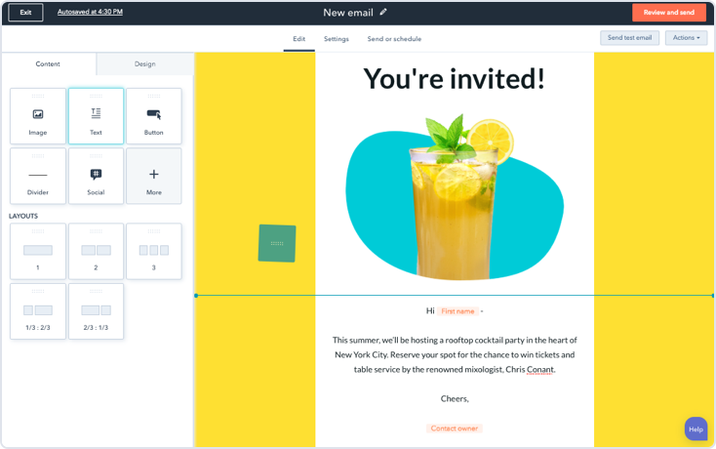
Get Started with HubSpot’s Free Email Tools.
HubSpot has free email marketing, sales, and hosting software for you and your company.
Get Free Email Software

Keep scrolling to templates
↓↓↓

Table of Contents | Thanksgiving & Black Friday Email Templates | 5
 | Christmas & Holiday Season Email Templates | 9
 | New Year & End-of-Year Email  Templates | 13
 | Other Holiday Email Templates | 18

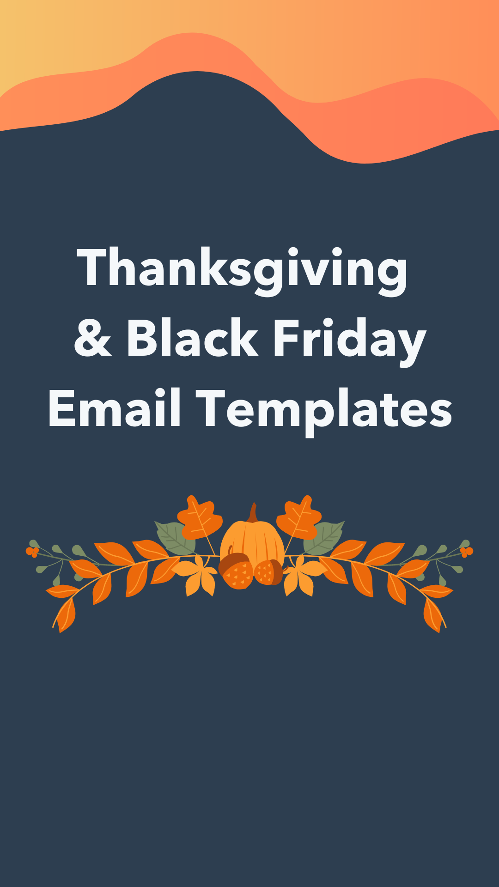

Black Friday Email Template

⬤ ⬤ ⬤

To: Your Recipient
From: You
Subject: A Black Friday Deal You Can’t Resist
Hi [Prospect name],

You didn’t think we’d be sitting out Black Friday, did you?

Companies like [company #1] and [company #2] have seen [% increase] in [relevant metric] after using [your company].

To help you see similar results, we’re offering [Black Friday offering] from now until [promo end date].

If you’re interested in learning how we can help with the heavy lifting this year, book some time on my calendar here: [Link to Meeting tool.]

Good luck deal hunting this Black Friday!
[Your name]

Thanksgiving Email Template — Year-Long Gratitude

⬤ ⬤ ⬤

To: Your Recipient
From: You
Subject: Something to Be Thankful for All Year
Hello [Prospect name],

In the spirit of the upcoming holiday, I want to give your team something it’ll be thankful for all year long.

[Product name] has helped hundreds of companies [explanation of what your product does] by [benefit of your company]. In the end, my clients have found they save [money/time/resources saved] every week on average. I want to help [prospect’s company name] see those same results.

If that’s of interest to you, consider booking a meeting with me to chat more here: [Link to meetings tool]

Hope to hear from you soon — either way, enjoy your Turkey Day!

Thanks,

[Your name]

Thanksgiving Email Template — Customer Gratitude

⬤ ⬤ ⬤

To: Your Recipient
From: You
Subject: Thanks for Working with Me
Hello [Prospect name],

I wanted to take a moment and thank you for working with me this year. I know you have a lot of choices, and I'm grateful you've chosen to spend time getting to know me and [company's product/service].

Happy holidays, and please let me know if I can do anything to make your life easier this season.

Regards,

[Your name]

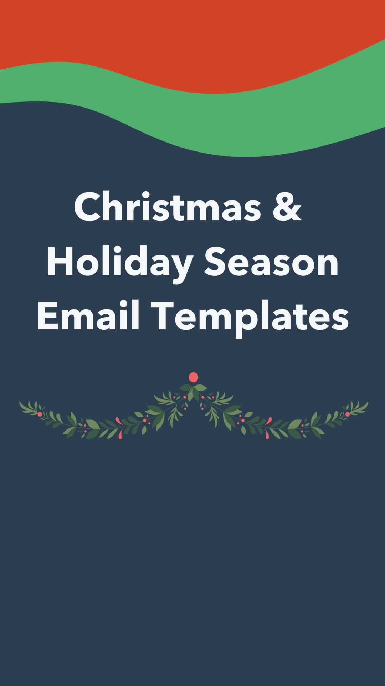

Happy Holidays Email Template — Problem Solving

⬤ ⬤ ⬤

To: Your Recipient
From: You
Subject: Give Yourself a Gift this Holiday Season
Hello [Prospect name],

I know it's the busy holiday season, but I wanted to say "hello" and remind you why we're such a good match. Think of each point as a small gift to yourself this year.

- [Insert prospect problem + how you can solve it] (i.e., Data entry is eating away at your time, but Company X can reduce entry time by X%.)
- [Insert product, service or feature]: [Insert reason/way it benefits your prospect] (i.e., Multi-user upload function: Kiss the days of waiting for your 10 teammates to finish uploading before you have a chance. This feature offers a solution to one of your biggest pain points.)
- [Insert budgetary fit + discount info for buying before end of year] (i.e., Our price + your budget = the perfect fit)

If you're ready to get that demo scheduled, grab some time on my calendar here: [Link to meetings tool]

Happy Holidays,

[Your name]

Happy Holidays Email Template — A Perfect Gift

⬤ ⬤ ⬤

To: Your Recipient
From: You
Subject: Inside: Something Better Than That Sweater From Aunt Mona
Hey [Prospect name],

We've all gotten gifts we wish had never been placed on this earth. But this gift I have for you? It's not one of 'em.

If you buy anytime between now and December 31, I can offer you [insert discount]. As simple as that!

If you're interested in learning more, give me a call or schedule some time on my calendar.

And if you'd rather go with Mona's sweater and get back to me after the first of the year — that's OK too.

Happy Holidays,

[Your name]

Happy Holidays Email Template — Discount

⬤ ⬤ ⬤

To: Your Recipient
From: You
Subject:
[Name] – it looks like you left something at the bottom of your stocking this year: a [discount] on [product]!

We want to make sure that you head into the new year with everything you need for [prospect company] to succeed. To help make that happen, we’re offering new customers a [discount] when they sign up for [product] by the end of the year.

Don’t miss out on the savings — it might be your last Christmas present until next year!

Go ahead and book time on my calendar if you’d like to take advantage of this special discount: [Insert calendar link]

Talk soon,
[Your name]

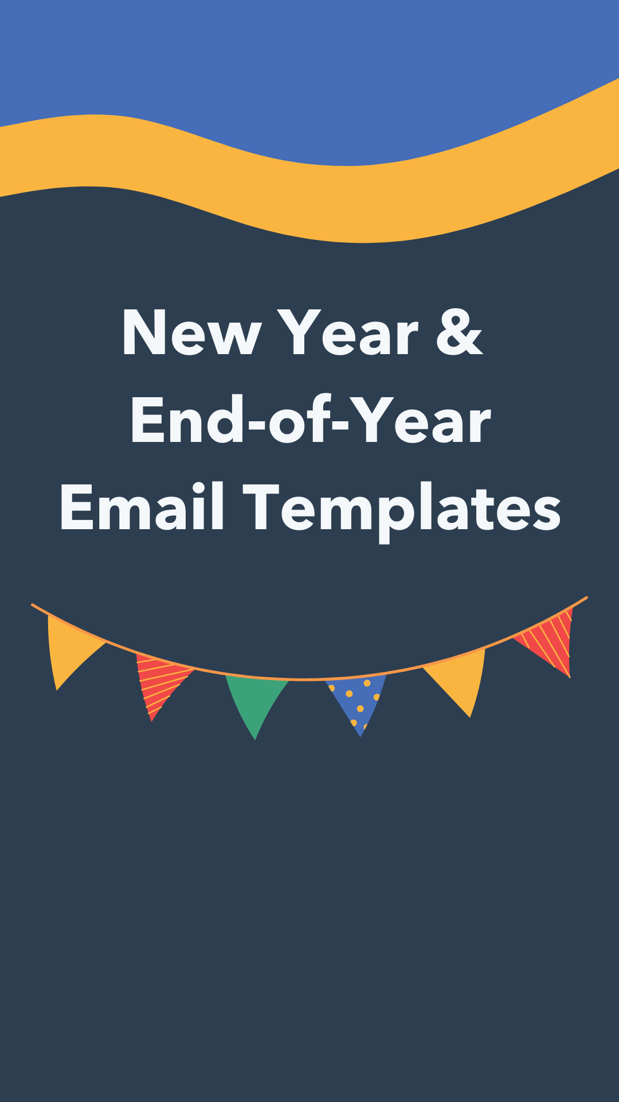

End-of-Year Email Template — Budget Allocation

⬤ ⬤ ⬤

To: Your Recipient
From: You
Subject: Put that Use-it-or-Lose-it Budget to Good Use
Hey [Prospect name],

It's that time again — the season where residual budgets disappear on December 31, and unused funds beg to be used before being absorbed into next year’s budget or reallocated to your nemesis team.

The good news is I can help! If you're ready to buy, I'd love to talk to you today. Simply reply to this email or book some time on my calendar here: [Link to meetings tool]

Let's put that leftover budget to work making your life easier and your boss impressed.

Happy Holidays,

[Your name]

End-of-Year Email Template — Busy Calendar

⬤ ⬤ ⬤

To: Your Recipient
From: You
Subject:
Hi [Prospect name],

If you’re anything like me, you’re cramming as much into your calendar as you can before taking the last few days of the year off.

But in the off chance you’ve got an open time slot on your calendar, I’m hoping we can quickly connect.

[Product] has helped companies like [prospect company name] save more than [savings] this year alone, and I know we can help you see similar results heading into the new year.

If you want to slot me in before you take off for the year, you can book a meeting with me here. [Insert calendar link]

Thanks!

[Your name]

End-of-Year Email Template — Open Calendar

⬤ ⬤ ⬤

To: Your Recipient
From: You
Subject: Can I Get Some Time on Your End-of-Year Calendar?
Hey [Prospect name],

The holidays are upon us and our (work) calendars usually look a little lighter. Before you turn on your out of office auto-responder, I'd love to grab a few minutes of your time for that demo you asked about.

I promise, it will fit neatly between your ugly sweater team lunch and the office white elephant party. If you're interested, feel free to grab time on my calendar here: [Link to meetings tool]

Happy Holidays,

[Your name]

End-of-Year Email Template — Post-Holidays

⬤ ⬤ ⬤

To: Your Recipient
From: You
Subject: Is Your Week Too Silent After Silent Night?
Hello [Prospect name],

If you're like me, you're making the most of this quiet week at the office. I'd love to talk to you about how you can start the year with a bigger bang than ever before.

I've got some ideas I'd love to run by you. Grab some time on my calendar here: [Insert calendar link]

Regards,

[Your name]

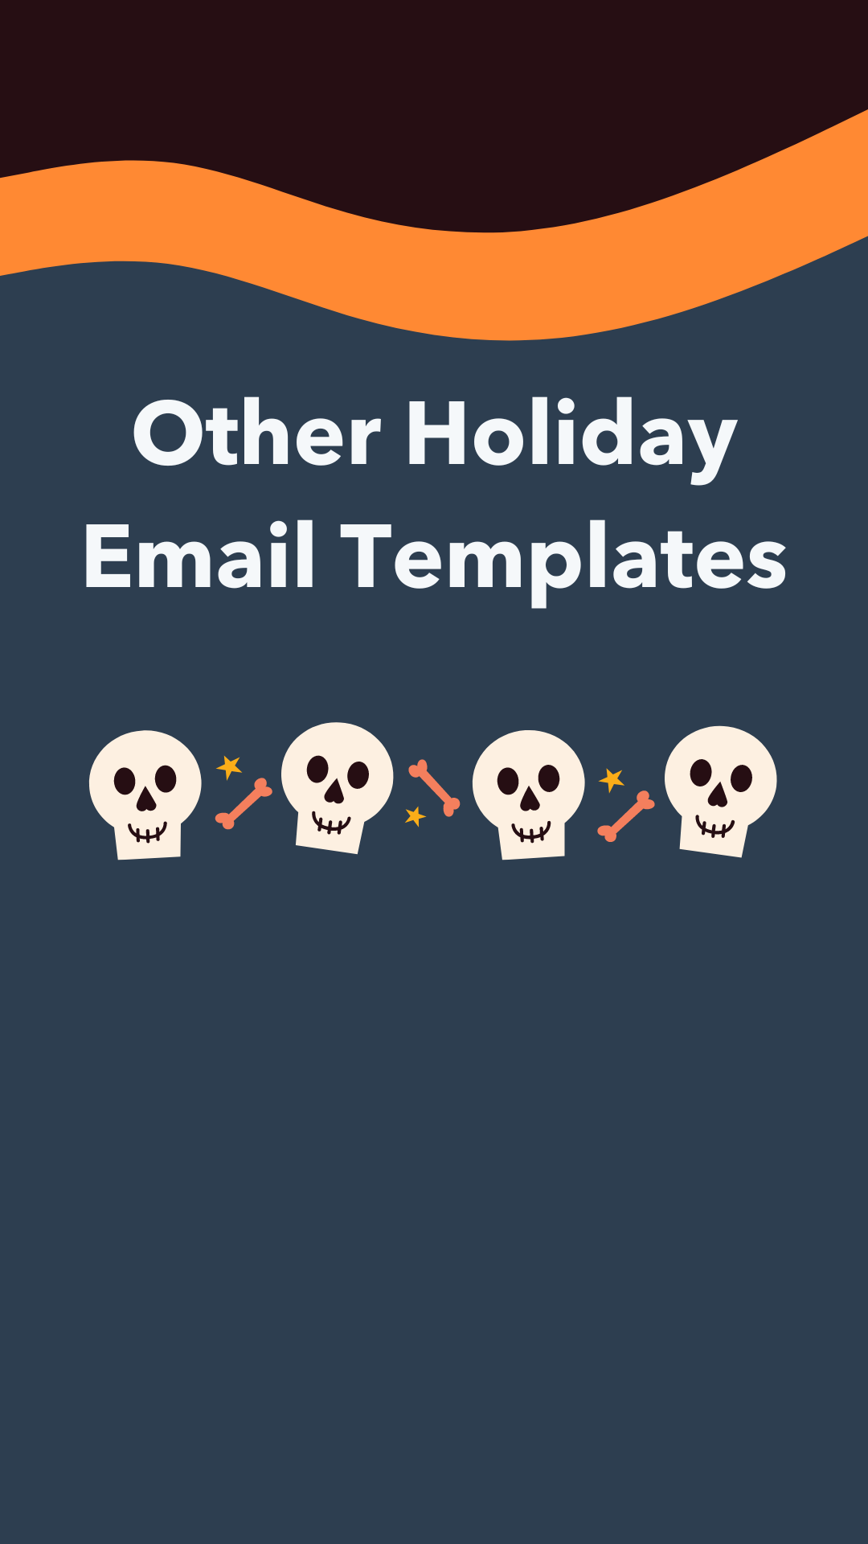

Holiday Email Template — Fourth of July

⬤ ⬤ ⬤

To: Your Recipient
From: You
Subject: Can You Squeeze Me in Before the Barbeque?
Hi [Prospect name],

Half of the country is out of the office this week and half has their eye on grilled food and friends.

Take this opportunity to put a 30-minute meeting on your mostly empty calendar and learn how [your company name] can help your marketing team bring in three times as many qualified leads.

I promise I'll let you go in plenty of time to get to your first BBQ of the weekend!

Regards,

[Your name]

Holiday Email Template — Labor Day

⬤ ⬤ ⬤

To: Your Recipient
From: You
Subject: Summer’s Over. The Savings Aren’t
Hello [Prospect name],

The cruises are over, the beaches are closed, and there's no better time to refocus your priorities and welcome a fall full of professional growth.

I'd love to take a few moments to explain how [your company name] can help your team meet goals faster than ever before and hit its end-of-year goals. Book time on my calendar here: [Insert calendar link]

I hope we can connect,

[Your name]

Holiday Email Template — Memorial Day

⬤ ⬤ ⬤

To: Your Recipient
From: You
Subject: Your Biggest Pre-Summer Opportunity
Hello [Prospect name],

It's officially summer and before I lose you to some well-earned vacation, I'd love to get a call scheduled to learn whether I can make your job easier — and hopefully help you take more vacation!

You can book time on my calendar here: [Insert calendar link]

Meeting with me is a great way to kill 30 minutes before you flip your OOO on.

Regards,

[Your name]

Holiday Email Template — Valentine’s Day

⬤ ⬤ ⬤

To: Your Recipient
From: You
Subject: Something Sweet this Valentine’s Day
Hi [Prospect name],

This Valentine’s Day, I want us to get together…

…So that I can show you a quick demo of [product name].

Trust me — you’ll love it.

Don’t take my word for it. Thousands of customers love [product name], too. Check out this video case study of our client, [client name], who used [product] to [purpose]. [Insert link to case study]

What do you think — can we make something happen this Valentine’s Day? If you’re interested (okay, enough puns), you can book a meeting with me here: [Insert calendar link]

Thanks,

[Your name]

Halloween Email Template

⬤ ⬤ ⬤

To: Your Recipient
From: You
Subject: No tricks — just treats!
Hi [Prospect name],

[Business challenge] can be pretty scary, huh?

Well, we want to change that. That’s why we’ve got a special treat for you — [discount] if you sign up for [company] by [deadline].

No tricks here. Just a surefire way to save [savings] and to save yourself from being haunted by [business challenge].

Who ya gonna call? Me, hopefully. Here’s a link to book a meeting with me: [Insert calendar link]

Thanks,
[Your name]

